Creating a Record Handout

You can create records from the **Home** area of Observe, by clicking the **+** icon next to the relevant template type in the Record Stats section. You can also create records by navigating to **Records** > then click **Create Record** and select the appropriate type of record from the options available.

*Click the icon to remove Observers/Owners if needed!*

*Click the tick box if you’re not sure of the record date yet, this can be altered when necessary.*

*This will tell you the current academic year in use.*

*While a date is not required to create a record, one must be entered to publish it.*

|  |  |
| --- | --- |
| **1.** | Select the category from the **Category** dropdown box.  Select the template from the **Template** dropdown box.  *Tip - The record name will automatically be populated based on selections, but you can click in and edit this if needed.* |
| **2.** | Click into the **Record Date** text box to select the date of the record. |
| **3.** | Click inside the **Observer/Owner List** box and search and select the appropriate Observer/Owner/s for the record. You can add up to 10! This would usually be the individual/s who will be responsible for completing the record and should have access to start, modify, publish and view this.  *As the record creator, you will automatically be added as an Observer/Owner on the right* *.* |

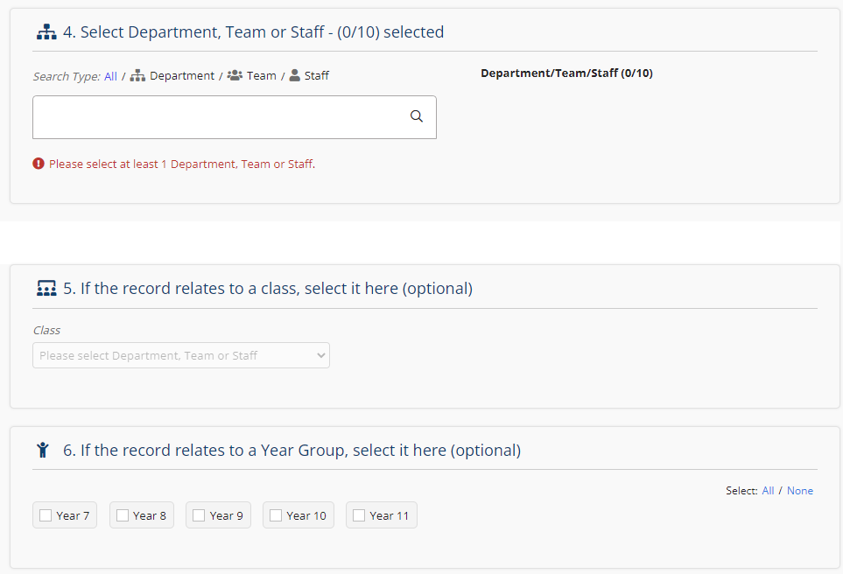

*Thanks for reading!*

*Select any Year Groups / Course Levels and Focus Groups you want to link to the record to help you filter your data once created.*

*You have the option of selecting a class context here if available, which will add information about the class being observed to the record!*

|  |  |
| --- | --- |
| **4.** | Click inside the **Department/Team/Staff** box.  **Select** the department, team and/or staff member that is being observed. You can add up to 10 combinations of these on one record! |
| **5.** | Optional – **Select** if the record relates to a class  *This allows you to see contextual information that has been imported about that class!* |
| **6.** | Optional – **Select** the year group/s or course level/s the record relates to, if applicable.  *This means you can filter and view performance by year group or course level in the reports!* |
| **7.** | Optional – **Select** if the record relates to any focus groups.  *This means you can filter and view performance by focus group in the reports!* |
| **8.** | Click **Create** at the bottom of the page to confirm your choices, then click **Start** on the next page to begin completing your record. |