
Adding a Reflection in Sisra Observe
Reflections allow you to add comments to a focus area, for example to ask for more feedback or to provide further explanations if needed.
To add a reflection to a record, either fast track to your records from the Home page, by clicking ‘Assigned to me’ for the appropriate type, or click ‘Records’. Then, click the record name then click ‘View’.
- Navigate to the appropriate focus area that you would like to add a reflection against. | Underneath the focus area, click  ‘Add +’ and select  ‘Add Reflection’.
 |  | 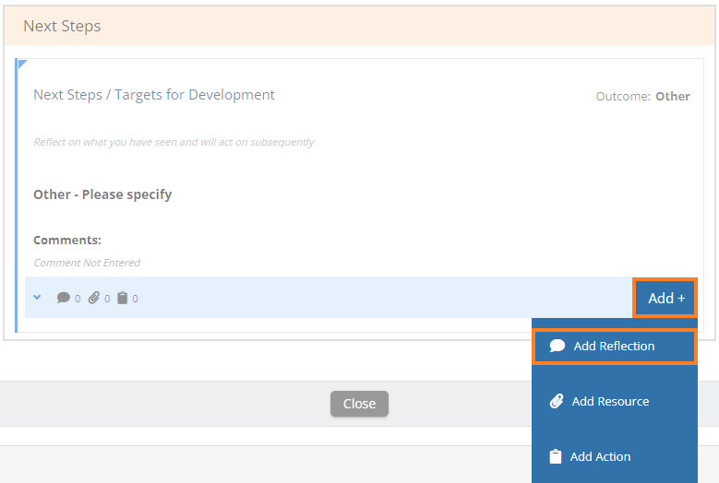
Type in your comments and click Save.  You can then close the record or repeat this for other focus areas you wish to add reflections against. | 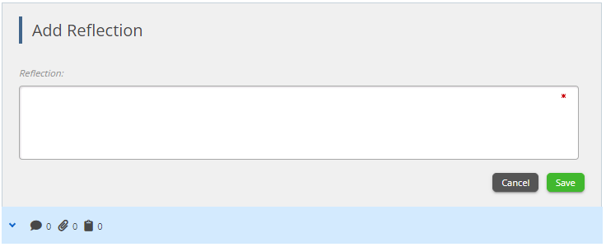 | Email notification - once you save your reflection, any observers or owners for this record will be notified by email.

Thanks for reading!

