
Your Home Dashboard, Event List & Records Area
When you first log into Sisra Observe, you will land on the Home page, which provides a handy personal dashboard, detailing any records assigned to you, records you have created, as well as the ability to create new records (if you have permission) straight from this screen.
You can also access your own Event List, to help you keep track of your outstanding and upcoming actions and their progress.
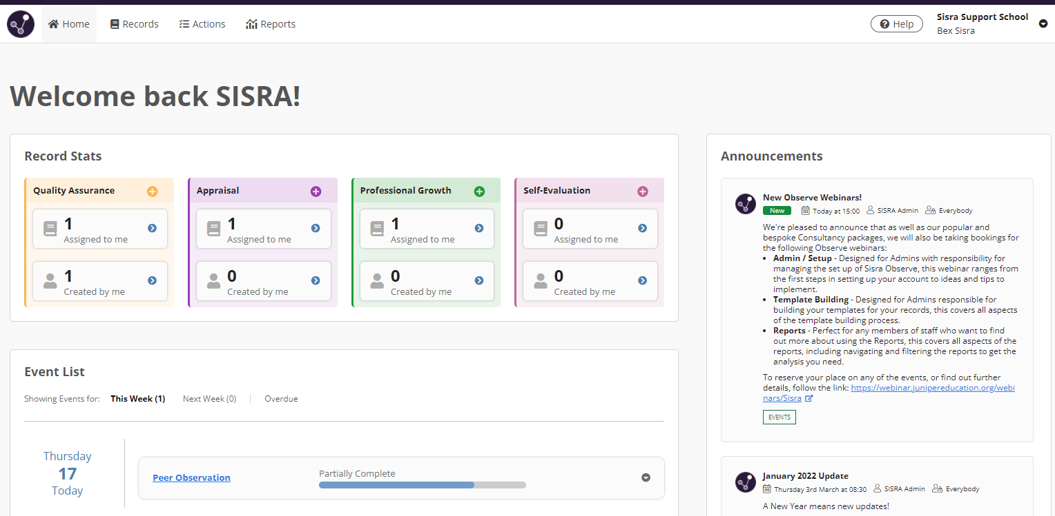

Help – Access our help centre, filled with user articles and handouts – to help you get the most from Observe!

Your account details – Manage your details, such as name, password, email address etc.!

Interactive dashboard – click to view records assigned to you, records you’ve created or click the + icon to create new records (depending on permissions)

Your interactive events list – View and filter your outstanding actions. View their progress and click on them to update!

Sisra Announcements – See the latest updates, posted by Sisra staff! From new features to handy tips.
You can also access your records and resources list by clicking Records.

Access the Actions list
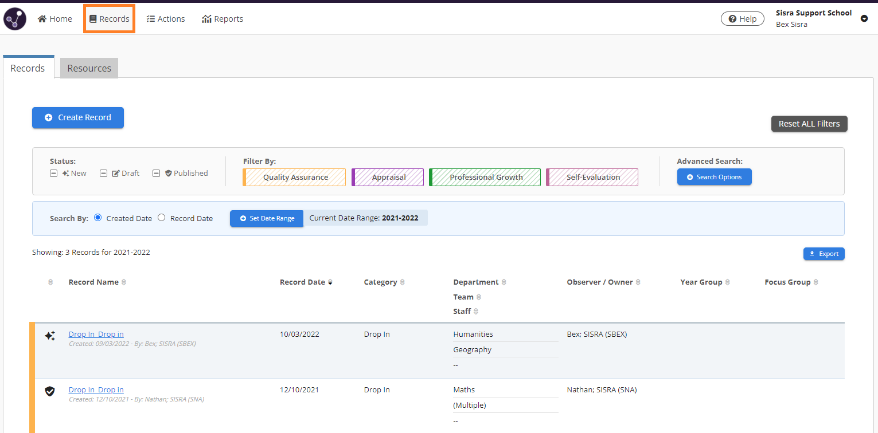

Click on a record to view, edit, start or publish it!

Create a new record!

Identify whether the record is New, in Draft or Published!

Filter the records list by type, staff, date, and more!

Click on the column headers to sort!

Switch between the Records and Resources lists
Thanks for reading!

