 **Adding a Resource in SISRA Observe**

You can upload and attach resources to a record to use as evidence or examples of best practice. To add a resource to a record, click ‘Records’ and within the Records tab click on a record name followed by ‘View’.

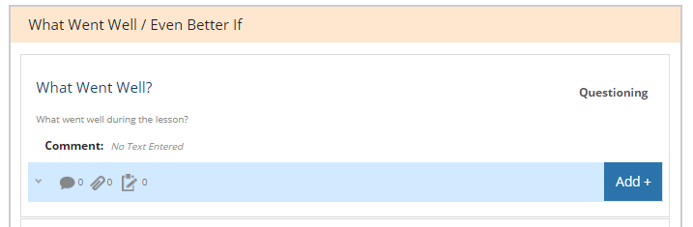

**1.** Navigate to the appropriate focus area to add the resource to (A1).



**2.** On the blue evidence bar underneath the focus area, click ‘Add +’. (A2).

*Please note, the evidence bar functionality is made available by your admin. If you can’t see the blue bar, speak to your organisation’s Observe admin.*

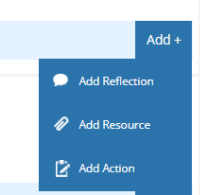

**3.** Click ‘Add Resource’ (A3).



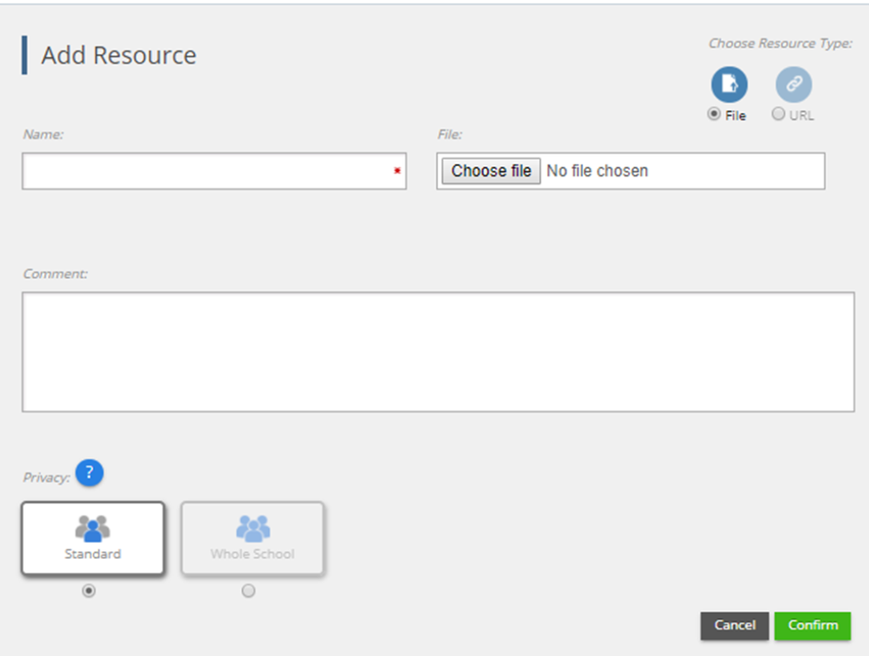

**4.** Select whether you want to attach a file or a web URL (A4).

**5.** Enter a name for your resource (A5) and then choose the file to upload or enter the web URL you want to attach (A6).

*Please note, Observe won’t allow you to attach video files, so if you do want to attach a video, we recommend hosting it on a website such as Dropbox or Google Drive, and entering the URL to the video as your resource.*

If your admin has enabled email alerts, once you save your resource, any observers for this record will be notified by email.

**6.** Enter a comment for your resource, if applicable (A7).



**7.** Next set the Privacy setting for your resource (A8).

* **Standard** – only people with access to this record will be able to access the resource.
* **Whole School / Organisation** – every Observe user in your account will have access to the resource. This can be really useful for sharing examples of best practice!

**8.** Once you’re happy, click ‘**Confirm**’ to attach the resource (A9). You can view all resources you have access to by navigating to Records > Resource List. From here, you can search for and download any resources you want to use.